Name __________________________________________________________________ Period ______

My Life Cave Art Mini-Project
Early humans may have used art as a way of helping themselves in their struggle for survival. Paintings of animals on cave walls are common. Perhaps this was thought to bring success when hunting or acted as a call for help from a spirit world the people believed in. The famous cave paintings at Lascaux in southwest France are about 18,000 years old. Stone Age artists also created sculptures from clay, ivory, bone, or carved stone.
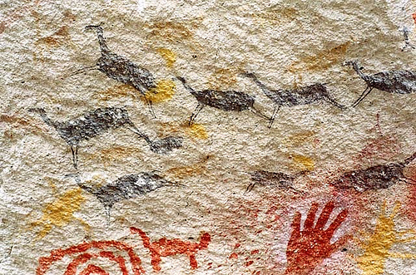
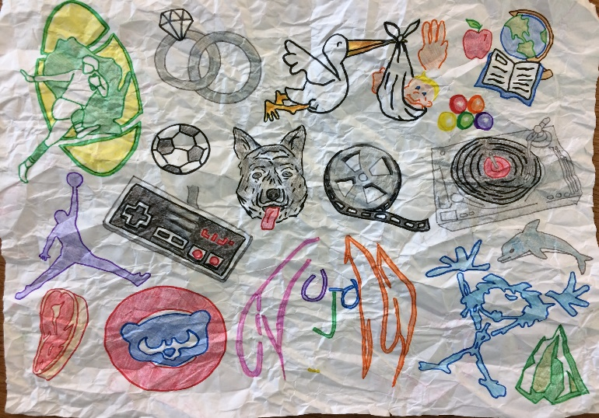
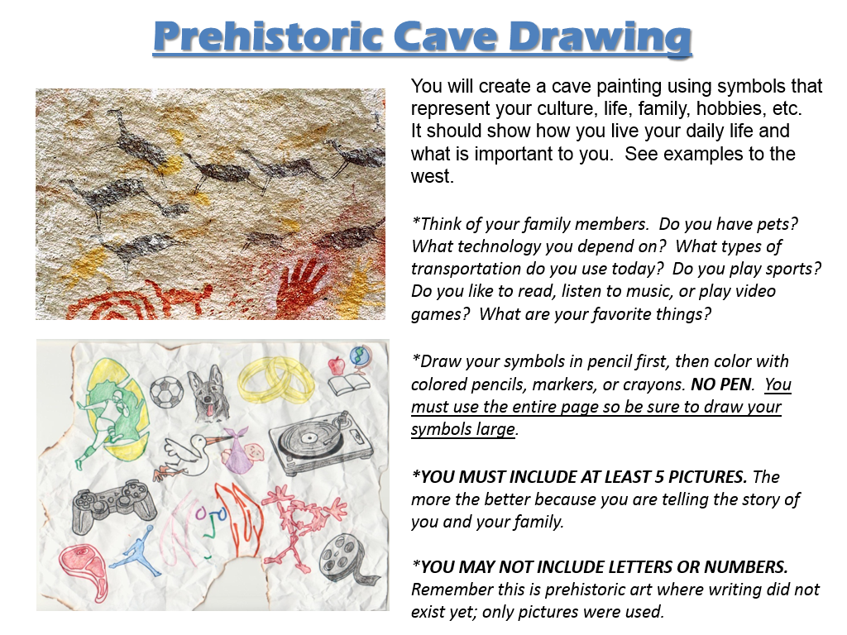

Please draw your picture in landscape mode. Before you turn in your art, check off the following about your drawing:
- NO words
- NO letters
- NO numbers
- Only pictures (AT LEAST 5)
- ALL pictures are colored

- **After you are done with your drawings, complete the back side of this paper.
You will turn in BOTH this page and your cave art!
Name __________________________________________________________________ Period ______

Write sentences explaining EACH of the symbols you have illustrated for your cave art.
(at least 5 symbols = at least 5 descriptive sentences)
1

________________________________________________________________________________
________________________________________________________________________________
________________________________________________________________________________
________________________________________________________________________________
2
________________________________________________________________________________
________________________________________________________________________________
________________________________________________________________________________
________________________________________________________________________________
3
________________________________________________________________________________
________________________________________________________________________________
________________________________________________________________________________
________________________________________________________________________________
4
________________________________________________________________________________
________________________________________________________________________________
________________________________________________________________________________
________________________________________________________________________________
5
________________________________________________________________________________
________________________________________________________________________________
________________________________________________________________________________
________________________________________________________________________________

Descriptive Sentences _____/5
_____%

Name: _________________________________________________________ Period: ______

*This will be the back side of your cave art. All drawings need to be on the other side.

